**Crude Project**

**Proudly Presents**

An ASIT Online Magazine web application documentation, developed by:

* Zwane Bandisa
* Simphiwe Ndzinisa
* Nxumalo Phumlani
* Lindelani Ndlangamandla

, ACCP Semester 3 students at the Advanced School of IT(ASIT) under the Royal Science and Technology Park in Eswatini.

**ACKNOWLEDGEMENTS**

First and foremost, we would love to appreciate the opportunity given to us to showcase our skills in Flutter App Development as an end-semester project. We would also like to express our special thanks of gratitude to our tutor Mr. Sunil, who chiseled us with the knowledge and skills, we found ourselves using in this project. We would also love to give ourselves the credit for humbly working together as a group to accomplish the project.

**Interface Requirements**

**Hardware/ Software Requirements**

**Hardware**

1. A minimum computer system that will help you access all the tools in the courses is a Pentium 166 or better

2. 64 Megabytes of RAM or better

3. Windows 98 (or higher if possible) 4. Java Virtual Machine

**Software**

Either or a combination of the following Software’s are to be used:

Android Studio

Firebase

**Test Data Used In The Project**

|  |  |
| --- | --- |
| **Type of test** | **Test performed** |
| Browser compatibility | Lack of support by the early browser for angular |
|  | Browser specific extension |
| Page display | Incorrect display of pages |
|  | Runtime errors |
|  | Display of images |
| Response time | Page load |
|  | Response time after a click |

**Screen Shots Of Flutter Crud Project:**

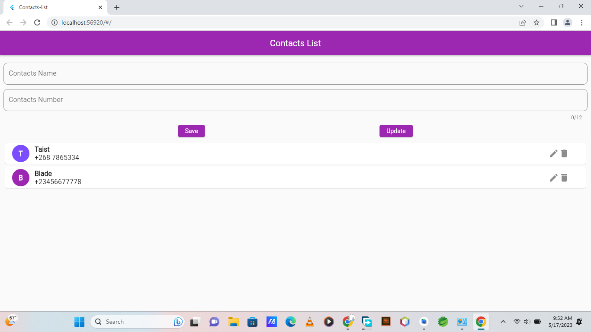

This is the landing UI when the app starts.

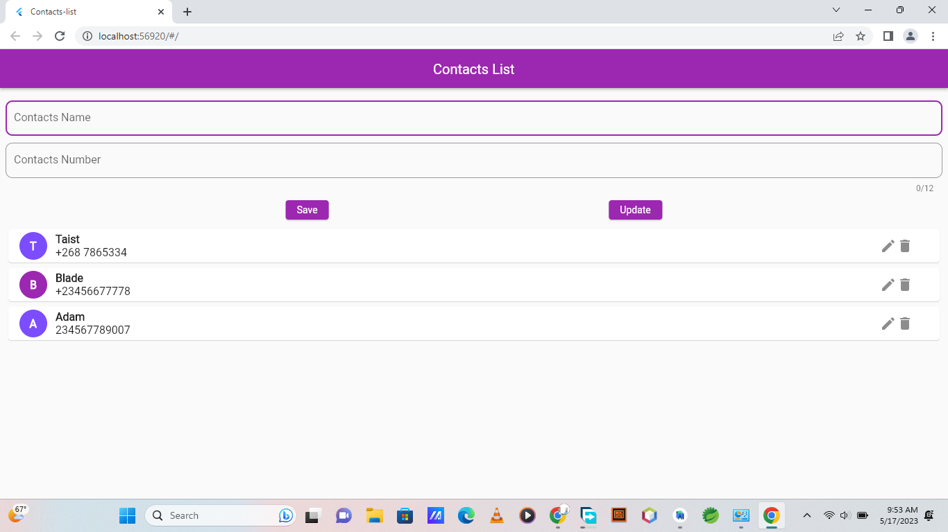Here we have added one user

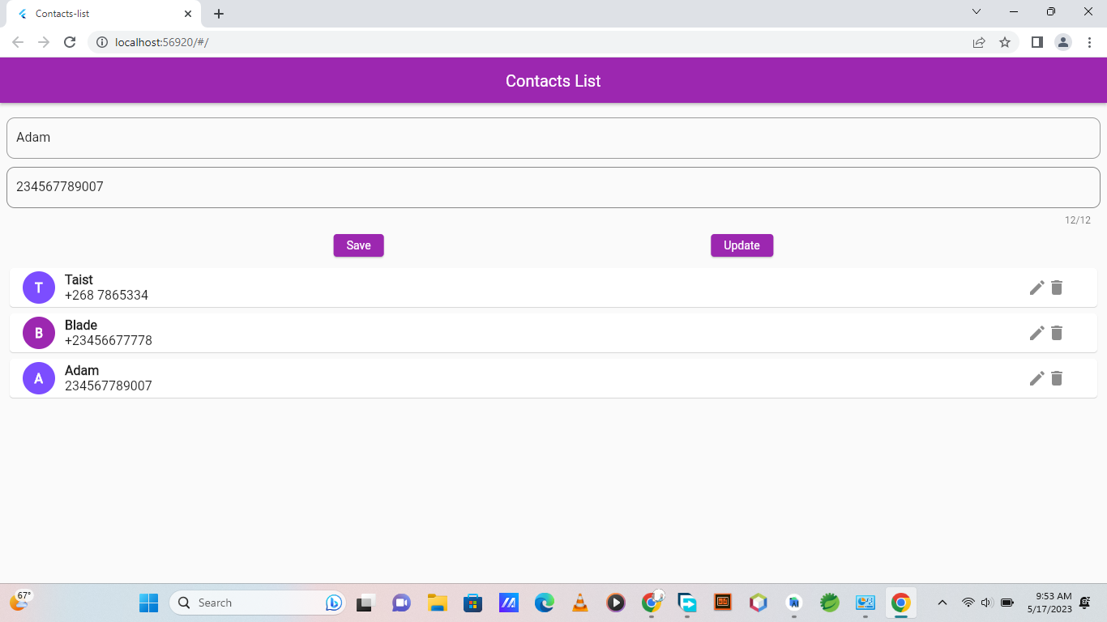

Here we update the user selected by clicking on it, and it shows on the fields.

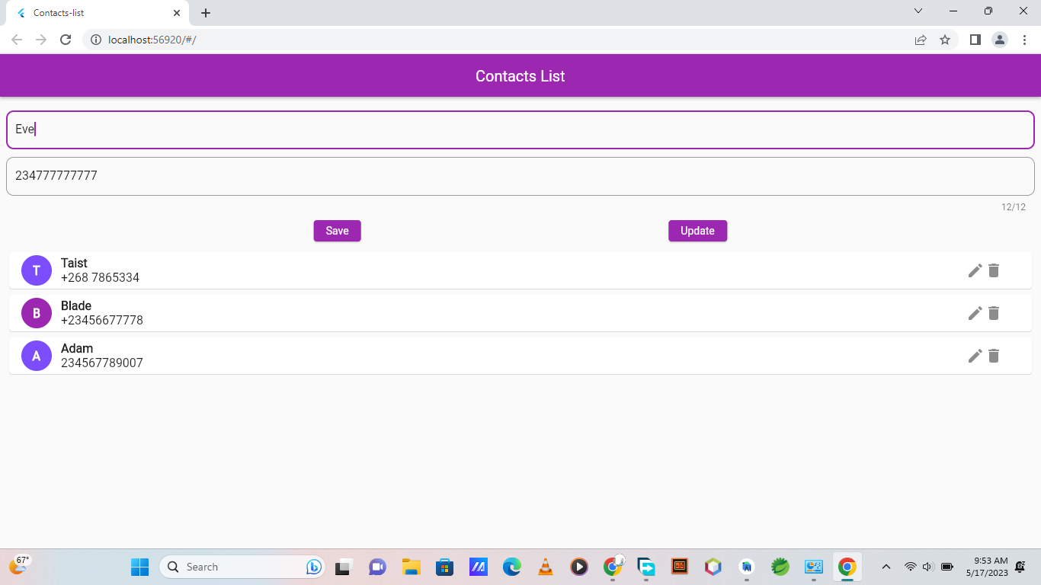

And here we are changing the Name of the user and number

This is the login editor form for only editors when they want to edit. It is called even when the go to the collection link.

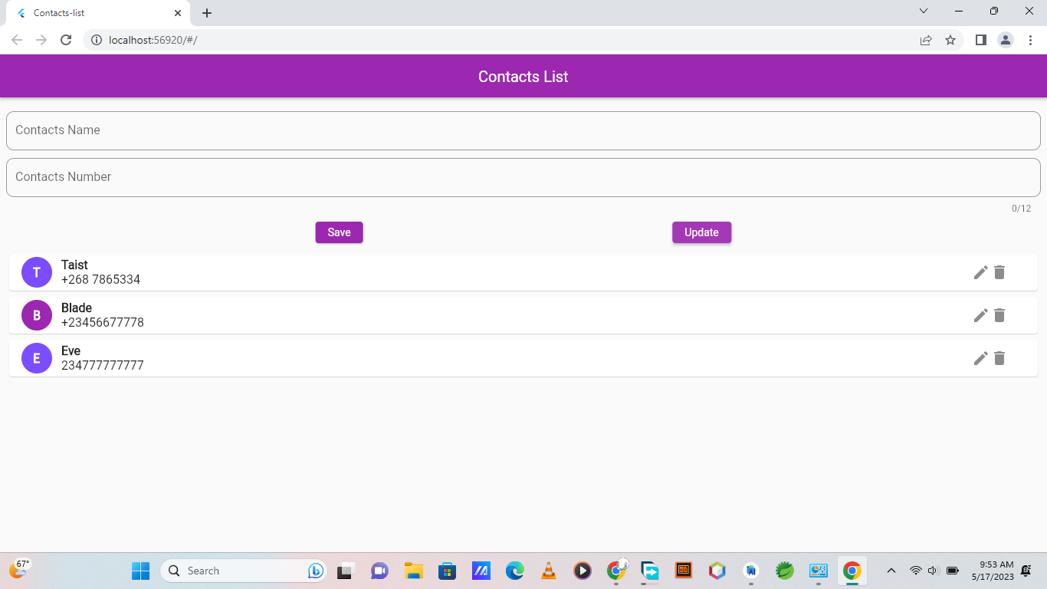

The user has been updated.

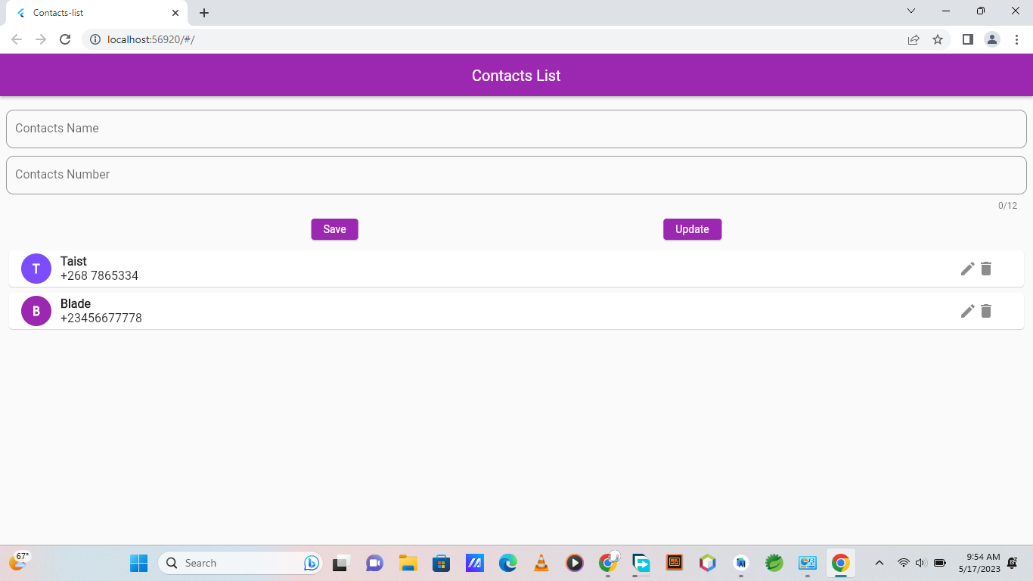

Now we have deleted by clicking on the delete icon.